1. **Consider the schema for Movie Database:**

**ACTOR (*Act_id, Act_Name, Act_Gender*)**

**DIRECTOR (*Dir_id, Dir_Name, Dir_Phone*)**

**MOVIES (*Mov_id, Mov_Title, Mov_Year, Mov_Lang, Dir_id*)**

**MOVIE_CAST (*Act_id, Mov_id, Role*)**

**RATING (*Mov_id, Rev_Stars*)**

**Write SQL queries to**

1. **List the titles of all movies directed by ‘Hitchcock’.**
2. **Find the movie names where one or more actors acted in two or more movies.**
3. **List all actors who acted in a movie before 2000 and also in a movie after**

**2015 (use JOIN operation).**

1. **Find the title of movies and number of stars for each movie that has at least one rating and find the highest number of stars that movie received. Sort the result by movie title.**
2. **Update rating of all movies directed by ‘Steven Spielberg’ to 5.**

**Solution:**

**Entity-Relationship Diagram**



**Schema Diagram**

***Actor***

|  |  |  |
| --- | --- | --- |
| ***Act_id*** | *Act_Name* | *Act_Gender* |

***Director***

|  |  |  |
| --- | --- | --- |
| ***Dir_id*** | *Dir_Name* | *Dir_Phone* |

***Movies***

|  |  |  |  |  |
| --- | --- | --- | --- | --- |
| ***Mov_id*** | *Mov_Title* | *Mov_Year* | *Mov_Lang* | *Dir_id* |

***Movie_Cast***

|  |  |  |
| --- | --- | --- |
| ***Act_id*** | ***Mov_id*** | *Role* |

***Rating***

|  |  |
| --- | --- |
| ***Mov_id*** | *Rev_Stars* |

**Table Creation**

CREATE TABLE ACTOR (

ACT_ID INTEGER (3),

ACT_NAME VARCHAR (20),

ACT_GENDER CHAR (1),

PRIMARY KEY (ACT_ID));

CREATE TABLE DIRECTOR (

DIR_ID INTEGER (3),

DIR_NAME VARCHAR (20),

DIR_PHONE INTEGER (10),

PRIMARY KEY (DIR_ID));

CREATE TABLE MOVIES (

MOV_ID INTEGER (4),

MOV_TITLE VARCHAR (25),

MOV_YEAR INTEGER (4),

MOV_LANG VARCHAR (12),

DIR_ID INTEGER (3),

PRIMARY KEY (MOV_ID),

FOREIGN KEY (DIR_ID) REFERENCES DIRECTOR (DIR_ID));

CREATE TABLE MOVIE_CAST (

ACT_ID INTEGER (3),

MOV_ID INTEGER (4),

ROLE VARCHAR (10),

PRIMARY KEY (ACT_ID, MOV_ID),

FOREIGN KEY (ACT_ID) REFERENCES ACTOR (ACT_ID),

FOREIGN KEY (MOV_ID) REFERENCES MOVIES (MOV_ID));

CREATE TABLE RATING (

MOV_ID INTEGER (4),

REV_STARS VARCHAR (25),

FOREIGN KEY (MOV_ID) REFERENCES MOVIES (MOV_ID));

**Table Descriptions**

DESC ACTOR;

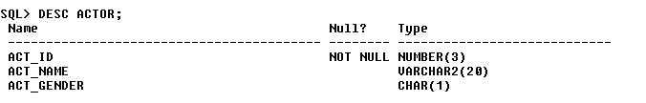

DESC DIRECTOR;

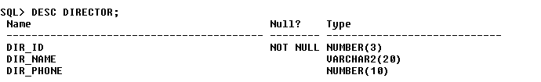

DESC MOVIES;



DESC MOVIE_CAST;

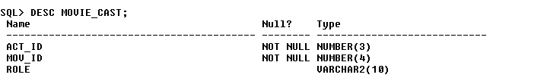

DESC RATING;

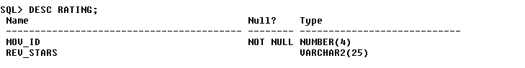

**Insertion of Values to Tables**

INSERT INTO ACTOR VALUES (301,’ANUSHKA’,’F’);

INSERT INTO ACTOR VALUES (302,’PRABHAS’,’M’);

INSERT INTO ACTOR VALUES (303,’PUNITH’,’M’);

INSERT INTO ACTOR VALUES (304,’JERMY’,’M’);

INSERT INTO DIRECTOR VALUES (60,’RAJAMOULI’, 8751611001);

INSERT INTO DIRECTOR VALUES (61,’HITCHCOCK’, 7766138911);

INSERT INTO DIRECTOR VALUES (62,’FARAN’, 9986776531);

INSERT INTO DIRECTOR VALUES (63,’STEVEN SPIELBERG’, 8989776530);

INSERT INTO MOVIES VALUES (1001,’BAHUBALI-2’, 2017, ‘TELAGU’, 60);

INSERT INTO MOVIES VALUES (1002,’BAHUBALI-1’, 2015, ‘TELAGU’, 60);

INSERT INTO MOVIES VALUES (1003,’AKASH’, 2008, ‘KANNADA’, 61);

INSERT INTO MOVIES VALUES (1004,’WAR HORSE’, 2011, ‘ENGLISH’, 63);

INSERT INTO MOVIE_CAST VALUES (301, 1002, ‘HEROINE’);

INSERT INTO MOVIE_CAST VALUES (301, 1001, ‘HEROINE’);

INSERT INTO MOVIE_CAST VALUES (303, 1003, ‘HERO’);

INSERT INTO MOVIE_CAST VALUES (303, 1002, ‘GUEST’);

INSERT INTO MOVIE_CAST VALUES (304, 1004, ‘HERO’);

INSERT INTO RATING VALUES (1001, 4);

INSERT INTO RATING VALUES (1002, 2);

INSERT INTO RATING VALUES (1003, 5);

INSERT INTO RATING VALUES (1004, 4);

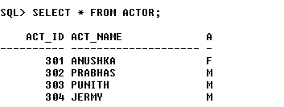

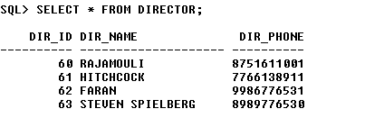

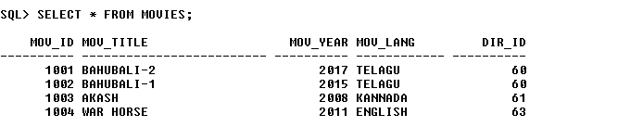

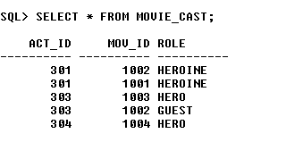

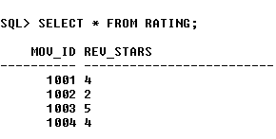

**Queries:**

1. **List the titles of all movies directed by ‘Hitchcock’.**

SELECT MOV_TITLE

FROM MOVIES

WHERE DIR_ID IN (SELECT DIR_ID

FROM DIRECTOR

WHERE DIR_NAME = ‘HITCHCOCK’);



1. **Find the movie names where one or more actors acted in two or more movies.**

SELECT MOV_TITLE

FROM MOVIES M, MOVIE_CAST MV

WHERE M.MOV_ID=MV.MOV_ID AND ACT_ID IN (SELECT ACT_ID

FROM MOVIE_CAST GROUP BY ACT_ID

HAVING COUNT (ACT_ID)>1)

GROUP BY MOV_TITLE

HAVING COUNT (*)>1;



1. **List all actors who acted in a movie before 2000 and also in a movie after 2015 (use JOIN operation).**

SELECT ACT_NAME, MOV_TITLE, MOV_YEAR

FROM ACTOR A

JOIN MOVIE_CAST C

ON A.ACT_ID=C.ACT_ID

JOIN MOVIES M

ON C.MOV_ID=M.MOV_ID

WHERE M.MOV_YEAR NOT BETWEEN 2000 AND 2015;

OR

SELECT A.ACT_NAME, A.ACT_NAME, C.MOV_TITLE, C.MOV_YEAR

FROM ACTOR A, MOVIE_CAST B, MOVIES C

WHERE A.ACT_ID=B.ACT_ID

AND B.MOV_ID=C.MOV_ID

AND C.MOV_YEAR NOT BETWEEN 2000 AND 2015;



1. **Find the title of movies and number of stars for each movie that has at least one rating and find the highest number of stars that movie received. Sort the result by movie title.**

SELECT MOV_TITLE, MAX (REV_STARS)

FROM MOVIES

INNER JOIN RATING USING (MOV_ID)

GROUP BY MOV_TITLE

HAVING MAX (REV_STARS)>0

ORDER BY MOV_TITLE;

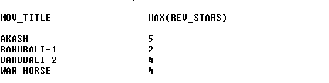

1. **Update rating of all movies directed by ‘Steven Spielberg’ to 5**

UPDATE RATING

SET REV_STARS=5

WHERE MOV_ID IN (SELECT MOV_ID FROM MOVIES

WHERE DIR_ID IN (SELECT DIR_ID

FROM DIRECTOR

WHERE DIR_NAME = ‘STEVEN SPIELBERG’));

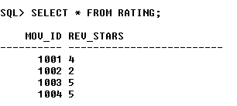

1. **Delete all the tuples whose review stars is less than 3.**

DELETE FROM RATING WHERE REV_STARS < 3;